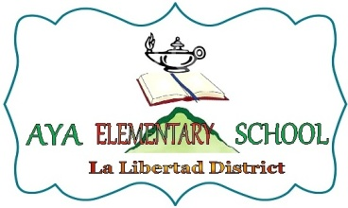Republic of the Philippines
DEPARTMENT OF EDUCATION
Region VII, Central Visayas
Division of Negros Oriental
District of La Libertad

June 24, 2014

APPLE PRINCESS SABANAL
Teacher - I
Aya Elementary School

Madam:

You are hereby designated as ENGLISH COORNINATOR of Aya Elementary School effective immediately upon the receipt of this designation.
Please do the responsibilities expected of you.
Thank you.

Very truly yours,

DICKY R. ELENTORIO
School Head

